***Champagne Perrier Jouet Grand brut***

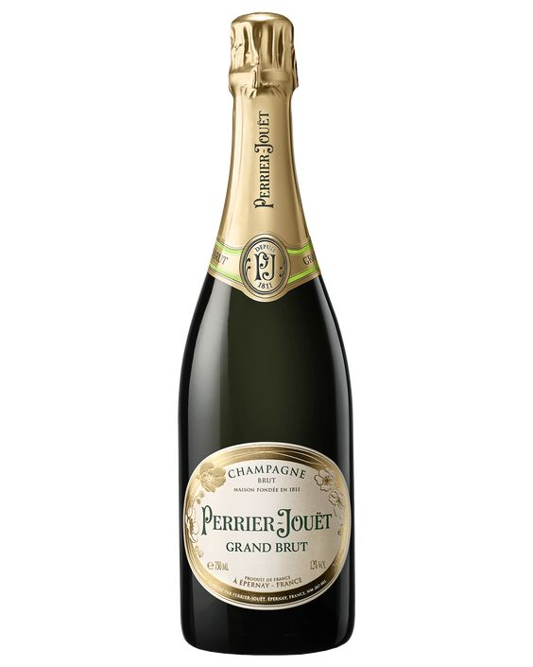

*"Perrier Jouet Grand brut Champagne, a blend of Pinot Noir (40%), Meunier (40%) and Chardonnay 20%. This Champagne is aged for a minimum of 36 months.  
  
Champagne is the drink for the elite because of its elaborate production, limited quantities, within the new French Champagne region known as Champagne as well as its much higher price tag than regular sparkling/sparkling.  
  
Champagne party is always a party of luxury and luxury, held on important occasions or in luxurious or 5-star restaurants. If you want to enjoy a delicious Champagne, treat and awaken your senses, you can't drink it casually and suddenly if it is not served properly.*